REFERENCE GUIDE
Manufactured
Home Checklist

You must first submit to Management for approval to move forward with a Manufactured Home

Affidavit of Affixture **We Cannot Take a Previous Transaction Affixture**
- State form DOR82528 (review for correct property form) *Should say “surrendered”
- Match to appraisal, engineer’s report, and/or IBTS reports:
  - property address, serial number, and HUD Tags
  - length and width, year built and make/model and manufacturer
- If not in the file, refer to pre-liminary title report for different recordings and request from title
- If subject property is a recurring client refinance, locate previous file and look at Shipped Documents for the Affidavit that was shipped
*TEXAS does not require Affidavit of Affixture; they require Manufactured Home Certificate*
Link to site: https://mhweb.tdhca.state.tx.us/mhweb/main.jsp

Engineer Certification
If an existing engineer cert is provided, confirmation that there have been any structural changes since original Engineer Cert. How?
- Have the original engineer confirm no changes. If the engineer is not available to provide an updated Engineer cert or a new Engineer cert will be required
- If refinance, and VIP closed the previous loan – The Underwriter will review and compare the old and new appraisal for changes and will confirm if new Engineer cert is required
Required for all manufactured homes (Exception: VA IRRRL’s and FHA Streamlines)

IBTS report
Identifies if a home was built up to HUD Manufactured construction and safety standards
- Ordered from: https://lvr2.ibts.org/#/LandingPage
- If exterior HUD Tags are not visible or removed per appraisal, Label Verification Letter
- If interior Data Plate is not visible or removed per appraisal, Date Plate/ Performance Cert
No expiration date for IBTS Report

Appraisal
- Page 1, HUD Date/Plate information matches supporting documentation
    - Serial Number, HUD Labels
    - Manufacturer’s Name, Model, and Date of Manufacture
- Visible pictures of Exterior HUD Labels and Interior Data Plate
    - If not, order IBTS reports as described above
- Private Road Maintenance agreement if applicable

Endorsements
- Title endorsements on the pre-liminary title report: 7, 7.1 or 7.2

Manufactured Home Fees and Invoices-needed even if paid POC by seller
Engineer Certification
- Check the date of Engineer Cert to confirm if new or existing
- New Engineer cert - Obtain invoice and disclose fee accordingly
- Existing Engineer cert - No invoice, therefore no fee to disclose
- Confirmation on who is to pay for it if invoice or who paid for it if POC
- Fee is entered on Itemization/Lines #810 and below, marked APR (under appraisal/credit/final inspection)
IBTS Report
- Check the date of the IBTS doc to confirm if new or existing-
- New – Obtain invoice and disclose fee accordingly
- Existing – No invoice, therefore no fee to disclose
- Confirmation on who is to pay for it if invoice or who paid for it if POC
- Fee is entered on Itemization/Lines #810 and below, marked APR (under appraisal/credit/final inspection)
If applicable (confirmation of who is to pay for it if invoice or who paid for it if POC)
- Septic
- Original Termite Report (if dirty, requires Supplemental)
- Water well testing

Other Required Documentation per Appraisal

Septic Certification
- Copy of clear septic certification
Termite Report
- Copy of clear original report. If not clear, supplemental report (dated within 90 days)
- Ensure property address is included on report
- Copy of signature page in to be signed folder
Water Well Testing
- Copy of Results

Encompass
- Property type is Manufactured Housing and Unit Type is Manufactured Multi-wide (Processing Summary Screen)
- If property has an HOA select Unit Type as PUD (Processing Summary Screen)
- Construction Method Type is Manufactured; Manufactured Home is Selected (URLA Part 4)
*See below for IBTS Report descriptions*

IBTS
To Be ORDERED: https://lvr2.ibts.org/#/LandingPage
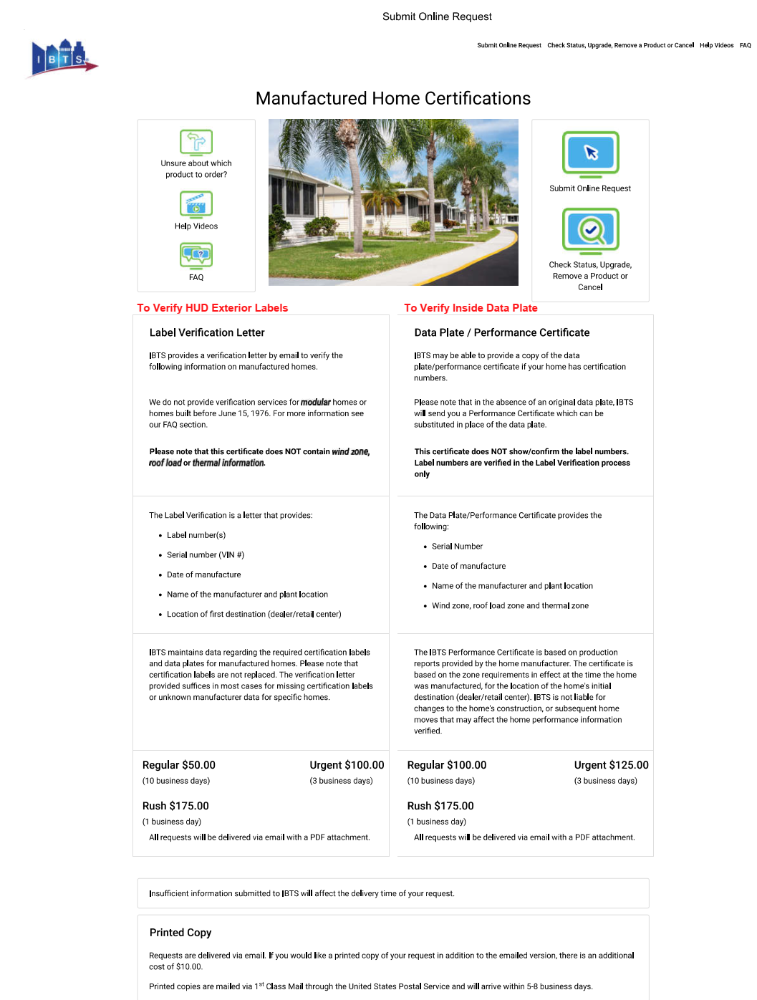
Reach out to your training team at training@vipmtginc.com
if you have any further questions

